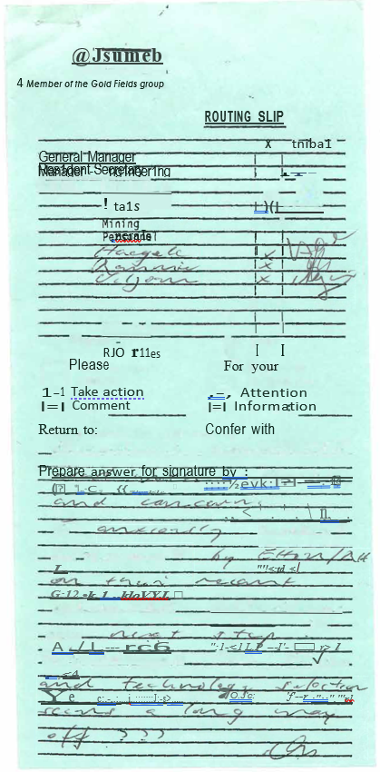

May 23, 1988

Smelter No. 172/88

by C. Viljoen

Distribution

H.A.R. Meiring

E.H.O Meyer

A. Sousa-Poza

R. Haegele/File

J. Rennie/R. & D. File

**Slag Fuming Project**

**Plasma Furnace**

A meeting was held on April 14, 1988 in the presence of the General Manager (others present: Meyer, Smit, Sousa-Poza, Haegele, Rennie), at which it was decided to vigorously pursue the previously suggested idea of collecting vaporized zinc and lead in a metal condenser adjacent to the furnace. Alternatives of this flowsheet would include

the recovery of germanium as either Geo from the gas phase (if the furnace is operated under mildly reducing conditions), or its recovery together with gallium from a metallic iron phase that forms under strongly reducing conditions and acts as a collector for both metals.

In view of this father surprising decision, test work carried out to recover metal values-from an oxide fume will be assigned a lower priori­ ty.

On April 22, a follow-up meeting was held (present Meyer, Sousa-Poza, Haegele, Rennie, Viljoen), at which C. Viljoen reported on the most re­ cent fuming test work carried out by MINTEK in both a 100 kW- and 200 kW plasma furnace. The flowsheet alternatives were again discussed with the view to obtaining zinc directly as a condensed metallic phase.

Further, topics were brought up to be discussed at the forth-coming meeting with representatives from Davy McKee, who were invited to visit Tsumeb. Publications indicate that Davy McKee has experience with plasma furnaces, and in particular with condensation of metallic zinc from plasma furnace fumes.

On May 9 - 10, a meeting was held with representatives from Davy McKee and MINTEK to further discuss plasma technology in fuming of our slag and the option of condensation of metallic fumes from a plasma furnace.

The presents were:

Davy McKee, U.K.

Davy McKee, S.A.

MINTEK

G.F.S.A.

T.C.L.

D.J. Moss

M.E. Gill

Dr. P. Kershaw

C.D. Reay

A. Newall

Dr. N. Barcza

T, Owen

E.H.O. Meyer

A. Sousa-Poza

Dr. R. Haegele

J. Rennie

C. Viljoen

The following options for plasma treating of blast furnace slag were dis­ cussed:

1. Fuming under mildly reducing conditions,

2. fuming under strongly reducing conditions, i.e. collecting both Ge and Ga in a metallic iron phase,

3. condensation of metallic vapors from fuming options 1 or 2,

4. collection of oxidic fumes from fuming options 1 or 2 with subsequent hydrometallurgical metal extraction route.

Option 4. was discarded due to the problems experienced with the development of the hydrometallurgical extraction route.

Differences in design principles of the McKee and MINTEK plasma furnaces was discussed at length, a summary of which is Appended.

Other salient points from the meeting were:

1. MINTEK

(a) MINTEK in conjunction with the University of Pretoria developed a condenser for the condensation of magnesium vapors from a plasma furnace. This 10,8 MVA plasma installation at Samancor will be commissioned in September, 1988 as a demonstration scale test unit. It was decided that Samancor be approached by Dr. Barcza for possible future blast furnace slag fuming and condensing test work on their facility.

(b) MINTEK proposed to, during the interim, conduct condensability test work under simulated plasma off gas conditions (i.e. to determine the relationship between condensing efficiency and metal vapor partial pressure).

(c) It was recommended that charcoal be used as reductant in future fuming test trials at MINTEK.

2. DAVY MCKEE

(a) A proposal for a one-month test campaign on their U.K. plasma installation with our slag was put forward, pending approval. No condensing test facility is however available.

(b) They are to approach I.S.P. on the applicability of the splash condenser for this particular application.

(c) A cost estimate for the envisaged slag fuming plant at Tsumeb was requested.

(d) Davy McKee indicated that they are willing to engineer a MINTEK-type plasma furnace as well.

(e) T.C.L. to be kept informed on the progress with the Davy McKee plasma installation in Australia (5 MW).

(f) Input on possible ways to recover minor metals from an Fe­ regulus was requested.

3. T.C.L.

(a) Some 2 tons of blast furnace slag and 200 kg of nut coal to be dispatched to England as soon as possible.

(b) The envisaged plasma off-gas composition to be submitted to Davy McKee.

(c) Conceptual flow sheets of the envisaged slag fuming plant to be submitted to Davy McKee.

APPENDIX

DIFFERENCES BETWEEN DAVY MCKEE AND MINTEK PLASMA DESIGNS

1. Both designs are based on the transferred arc principle, i.e., the furnace bath forms an ode.

2. Both designs make use of a direct current (D.C.} power supply.

3. Davy McKee based their design on the water-cooled tungsten tip cathode (plasma torch or gun. The rate of water-cooled electrode erosion is largely a function of current and hence lower rates are attained only

at conditions that allow high voltages which can only be attained by in­ creased arc lengths i.e. "long arcs11• MINTEK uses graphite electrodes which can be operated economically with both low voltage/high current or high voltage/low current, i.e. any arc length, although, arc stability and hence the risk of stray arcs increases with arc length.

Water cooled electrodes form more stable long arcs than graphite electrodes.

4. Heat dissipation by radiation is considerable in the case of long arcs. In order to utilize this radiative heat from their long arc, the McKee furnace is based on the Noranda cyclone sleeve feeding patent. The feed is pneumatically conveyed and tangentially introduced into the sleeve surrounding the long arc, · requiring large amounts of carrier gas. The MINTEK short arc furnace utilizes an open-bath design with no specific interaction between feed material and plasma-arc column, feed being introduced by gravity.

5.Due +o the excessive radiation heat dissipation with long arcs localized overheating at the bath arc attachment might be lower than with the graphite short arc where virtually all energy is transferred as heat into the bath. This could have a bearing on the amount of "undesirables" reporting to the fume.

6. Residence ·time appears to be more controllable in the sleeve/bath design

{McKee} as opposed to the open-bath smelting operation. This difference could be even further pronounced with continuous tapping.

7. Power levels greater than about 7 MW in a single water cooled electrode are not commercially available as yet, whereas graphite electrodes can operate at current levels allowing power levels of 50 MW to be reached {100 kA x 0.5 kV).

8. The possibility of applying a graphite electrode under long arc conditions in the McKee sleeve furnace exists, although arc stability and thus the risk of stray arcs to the sleeve might be a problem.